DREAMS AND NIGHTMARES
Vocabulary

- Dream of / about –soñar con
- Reality – realidad
- Fantasy –fantasía
- Scary – miedo de
- Scared –asustado
- Terrifying –terrorífico
- Terrified –aterrorizado
- Meaning –significado
- Recurrent dream –sueño recurrente
- Sleepy –somnoliento
- Asleep –dormido
- Awake –despierto
- Wake up –despertarse
- Fall asleep –quedarse dormido
- Tired –cansado
- Exhausted –exhausto
- Obsessed –obsesionado
- Escape –escapar, evadirse de
- Mind –mente
- Brain –cerebro
- Death –muerte
- Die –morir
- Dead –muerto
- Sorrow –dolor, tristeza
- Sadness –tristeza
- Unhappiness –infelicidad
- Commit suicide –suicidarse
- Happiness –felicidad
- Joy –alegría
- Happy –feliz
- Pleasing –agradable
- Sound asleep –profundamente dormido
- Noise –ruido
- Scream –grito
- Laugh –reír
- Laugh out loud –reirse a carcajadas
- Alarm clock –despertador
- Ring / rang / rung –sonar (teléfono, timbre, despertador)
- Family matters –asuntos de familia
- Problems at work / school –problemas en el trabajo / colegio
- Relationship –relación
- Routine –rutina
- Habit - hábito
- Research –investigación
- Psychologist –psicólogo
- Psychiatrist –psiquiatra
- Scientist –científico
- Scientific –científico (adjetivo)
- Strange - extraño
- Accident –accidente
- Mystery – misterio
- Mysterious –misterioso
- Ghost –fantasma
- shadow –sombra
- Pillow –almohada

Questions
- Do you think dreams can be interpreted?
Dreams are the unconscious mind that tries to solve problems that the concious mind can not.
- Do dreams have to do with real problems?
Dreams show u sour preocupations and attachments to our life. Seeing your boyfriend in your dreams represents your waking relationship (real life).
- Do you forget your dreams?
I usually forget my dreams
- Can you control your dreams?
I sometimes think about what I would like to dream before going to bed.
- When you wake up in the middle of the night, do you stop dreaming or do you go on dreaming?
My dreams are usually very pleasant but occasionally I wake up scared.
- Do you think dreams should be analized by psychologists?
No, I love analyzing them and thinking about what they might mean to my life.
- When you have had a strange dream and you don’t remember it, don’t you think you should have written about it as if it were a story?
It’s a good idea to write down every dream I have. I should write about everything I recall. I would like to write down in present tense as if it’s happening now.
- Do you have any recurrent dreams? Introduction.
- If you had dreamt about something unpleasant (desagradable), would you be obsessed with it the
whole day?
No, I try my best to remember them but I think it is only my curiosity. All my wisdom books tell me that life is a hidden puzzle and dreams are the pieces.
- Do you meet new people in your dreams or do you dream about the people you know?
- Do you like dreaming? Why / why not? Do you often have nightmares?
Only if they are good dreams and I can remember them. I sometimes dream nightmares.
- Do you feel scared when you hear noises at night?
Yes, I’m mos terrified when I hear people shouting. Sometimes my cat seems to see and hear things too.

Tell a dream
Introduction
- The scariest dream I have ever had is one that I've had about seven or eight years.
- I've had a recurring nightmare for about 6-7 years now that I have no idea where it came from.
Narration
- It starts with a first person view of a girl - shortish black hair, round face, piercings
- She walks towards me, stops, turns and starts laughing at me
- I can see her "parents" in the background and then she disappears.
Feelings
- It makes me feel very scared, maybe terrified.
- I feel like my eyes are open, I can't move and I can feel the bed
- It’s as if someone is breathing on my neck or a woman whispering things like "Hello" or "I can see you" into my ear very softly...
- I feel like I'm awake and that is the worst part but it's a false awakening and I'm in sleep paralysis.
Final
- A bit later I'm finally able to wake myself up.
- It took me awhile to believe my dreamn because it feels so real.
The end
- Now, I'm able to stop it once the nightmare appeared because I can recognize it and then do my best to become "wake" wake myself up.
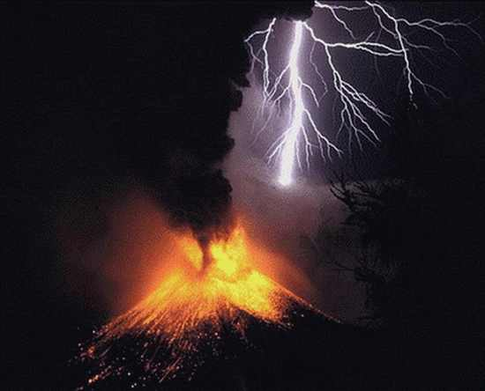
Meanings
Natural Disasters.
Dreaming about being caught for example in a tornado.
These types of nightmares are said to indicate a fear or anxiety in the person having the dream.
Seeing the Dead
In this type of nightmare, you feel as you are being contacted by someone who is dead. Someone you know who has recently passed away.
These types of nightmares can/could be associated with an inability to let go. You can’t cope with her/his loss.
Missing Important Events
Nightmares about missing an important appointment is common in people who live a high-pressure life. These types of nightmares are often linked to anxiety about failing or coming up short.
Injuries
When people experience nightmares of being injured, the cause is often some feeling of weakness in their own personal lives.
Partner Leaving
This type of nightmare can also be caused by feelings of insecurity in the relationship where someone feels they are not good enough for their partner.
Being Trapped
Dreams about being trapped are quite common for individuals who suffer from claustrophobic anxiety, in which a person has a fear of being in small spaces. However, this type of nightmare can also be experienced by people who are afraid of not being able to get out of their current situation,
Falling
Nightmares about falling are often a representation of anxiety in your personal life about not being in control of yourself. These anxieties are often due about money, relationships, careers or some kind of abuse.

