Modal Verbs in the Passive Voice
(modal verb) + be + past participle
1. Pancakes can be made on a stove. (possibility) | CAN BE MADE
2. Bikes may be ridden on this bike path. (permission is given) | MAY BE RIDDEN
3. People must be warned that there are crocodiles in the area. | MUST BE WARNED
4. Her work has to be done by tomorrow or she'll get in trouble with her boss. | HAS TO BE DONE
5. Something should be done about global warming or else some types of penguins will perish from the earth. | SHOULD BE DONE
6. A lot of cows can be raised on a productive farm. | CAN BE RAISED

(past modal verb) + have + been + past participle

Modal | Past Tense Form
can | could
will | would
may | might
shall / should | should
is going to | was/were going to
(be) able to | was/were able to
have to | had to

1. Pancakes can be made on a stove.  They could have been made in the oven, but they wouldn't have turned out so good. (past possibility) | CAN BE MADE  COULD HAVE BEEN MADE | 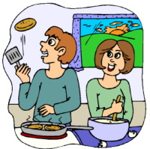
2. Bikes may be ridden on this bike path.  Earlier, these bikes might have been taken through the streets of Minneapolis. (permission is given) | MAY BE RIDEN  MIGHT HAVE BEEN TAKEN
3. Flowers will be grown in my garden again this summer.  Corn would have been grown last summer, but corn stalks take up too much space. | WILL BE GROWN  WOULD HAVE BEEN GROWN | 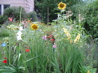
4. Her work has to be done by tomorrow or she'll get in trouble with her boss.  Originally, It had to have been done by yesterday, but her boss gave her extra time to finish it. | HAS TO BE DONE  HAD TO HAVE BEEN DONE
5. Something should be done about global warming or else some types of penguins will perish from the earth.  Something should have been done many years ago but wasn't. | SHOULD BE DONE  SHOULD HAVE BEEN DONE | 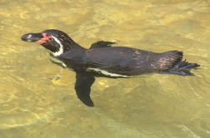
6. A lot of cows can be raised on a productive farm.  Corn could have been raised instead, but this farmer decided to grow grass. He's a smart farmer! | CAN BE RAISED  COULD HAVE BEEN RAISED | 