Inglés. Tema 1
VOCABULARY
Countries and nationalities

  - Australia:
  - Australiano:
  - Belgica:
  - Belga:
  - Canadá:
  - Canadiense:
  - China:
  - Chino:
  - Colombia;
  - Colombiano:
  - Ecuador:
  - Ecuatoriano:
  - Francia:
  - Francés:
  - Irlanda:
  - Irlandés:
  - Japón:
  - Japonés:
  - Méjico:
  - Mejicano:
  - Marruecos:
  - Marroquí:
  - Rumanía:
  - Rumano:
  - España:
  - Español:
  - Inglaterra:
  - Inglés:
  - Estados Unidos:
  - Estaunidense:

Family

  - Abuelo:
  - Abuela:
  - Padre:
  - Madre:
  - Hermana:
  - Hermano:
  - Tío:
  - Tía:
  - Primo:
  - Prima:
  - Bisabuelo:
  - Bisabuela:
  - Hijo:
  - Hija:
  - Marido:
  - Esposa:
  - Cuñada:
  - Cuñado:
  - Suegro:
  - Suegra:

Interrogative with the verb TO BE
W/H + is/are + subject?
Negative form:
Subject + am/is/are + not
GRAMMAR

Complete with the verb to BE:

Peter Baker from Manchester, but Paul and John from London. Manchester and London cities in England. Hamburg a city in Germany. Sandra at school today. Jack and Peter her friends. They in the same class. Mr and Mrs Baker on a trip to the USA to visit their cousin Anne. She a nice girl. Peter says: "My grandfather in hospital. I at home with my grandmother." What time it? It 8 o'clock. you tired? No, I not.

Complete:

  - you tall ? No,
  - the dog black? Yes,
  - I strong? Yes,
  - the food good? No,
  - they dogs? No,
  - the doctor in his office? Yes,
  - the children in school? No,
  - the water cold? No,
  - it hot outside? Yes,
  - the floor clean? Yes,
  - your teacher English? No,
  - Peter American? Yes,

Complete:

  - ¿Cuál es tu nombre?:

  - ¿De dónde eres?:

  - ¿Cuándo es tu cumpleaños?:

  - ¿Cómo estás?

  - ¿Qué edad tienes?:

  - ¿Quién es carlos?:

  - ¿Por qué es tu nombre especial?

  - Tu no eres Leonés

  - Tus padres no son de Valencia de D. Juan.

  - Yo no soy listo.

Write questions as in the example.

you / a good singer --> Are you a good singer?
1. David Bisbal / your favourite pop star
2. we / from England ?
3. you / twelve?
4. your friends / good students?
5. Messi / your favourite footballer ?
6. she / a good teacher?
7. Martha / a tennis player?
8. the dogs / under the table?
9. the cat / in the garden?
10. he / happy?

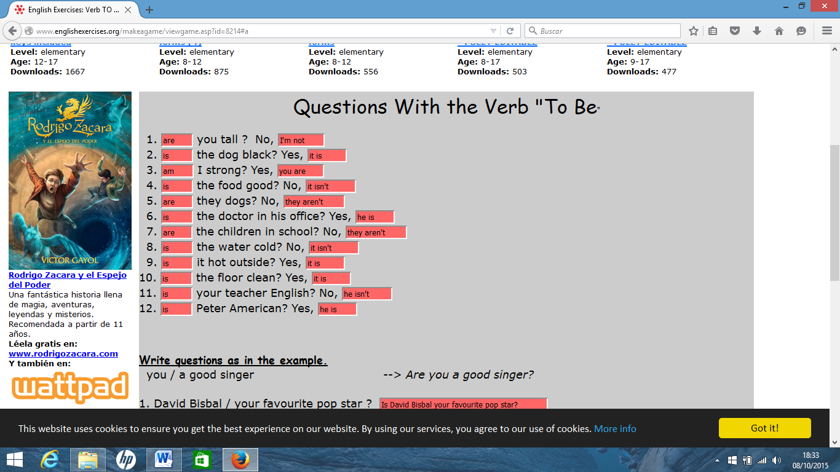

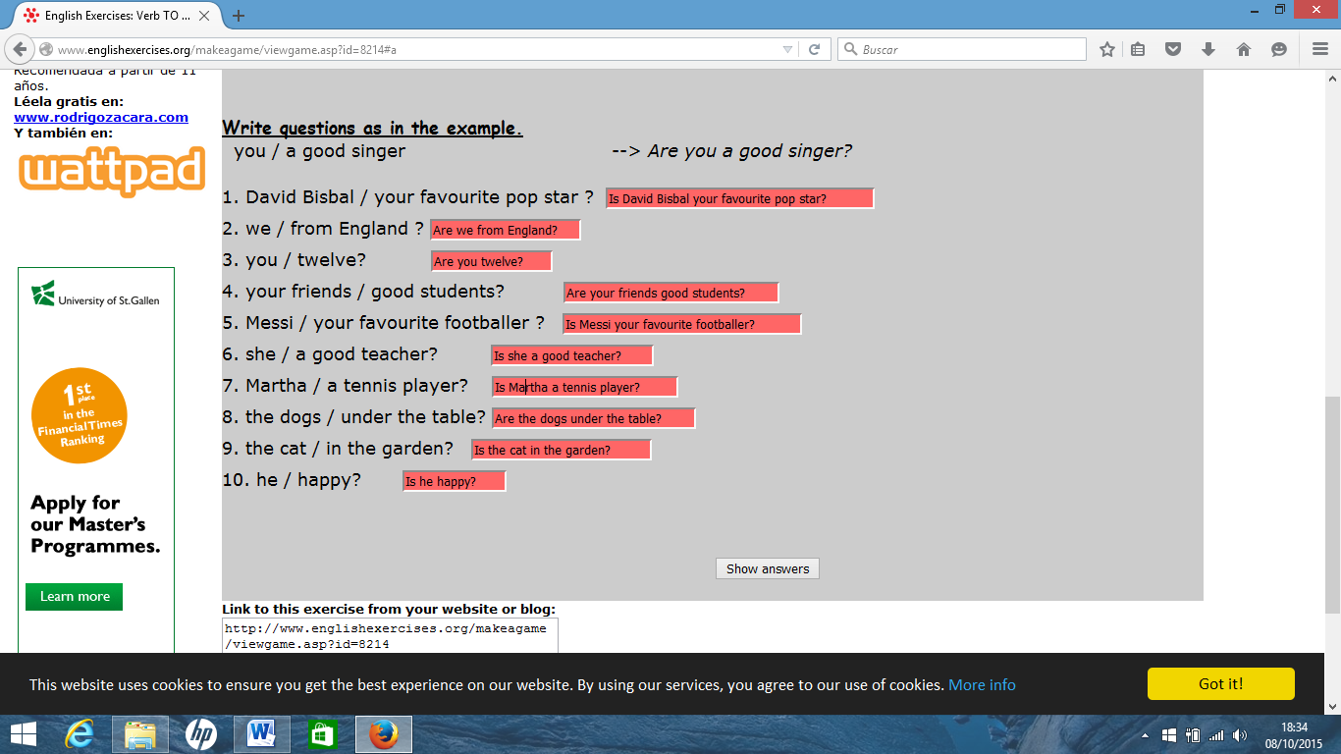

Peter Baker is from Manchester, but Paul and John are from London. Manchester and London are cities in England. Hamburg is a city in Germany. Sandra is at school today. Jack and Peter are her friends. They are in the same class. Mr and Mrs Baker are on a trip to the USA to visit their cousin Anne. She is a nice girl. Peter says: "My grandfather is in hospital. I am at home with my grandmother." What time is it? It is 8 o'clock. Are you tired? No, I am not.

