Inglés. Tema 4
VOCABULARY
La ciudad

  - Farmacia
  - Iglesia:
  - Cine:
  - Hotel:
  - Biblioteca:
  - Museo:
  - Kiosco de prensa:
  - Restaurante:
  - Escuela:
  - Zapatería:
  - Centro commercial:
  - Centro de deportes:
  - Supermercado:
  - Estación de metro:
Paisajes

  - Arena:
  - Playa:
  - Árboles:
  - Bosque:
  - Agua:
  - Río:
  - Montañas:
  - Nieve:
  - Hielo:
  - Lago:
  - Isla:
  - Olas del mar:

GRAMMAR
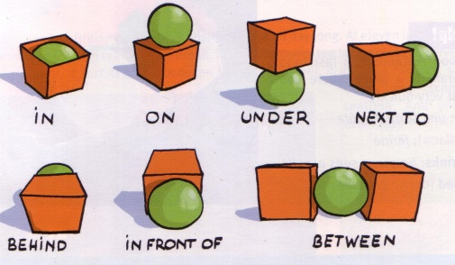
There is, There isn’t. Singular. There are. There aren’t. Plural. Prepositions of place
Complete with: There is/ There are
- There… a bag on the table.
- There… a calendar on the wall.
- There… two posters in my room.
- There… a banana in this basket.
- There… six chairs in the kitchen.
- There… lots of books in the shelf.
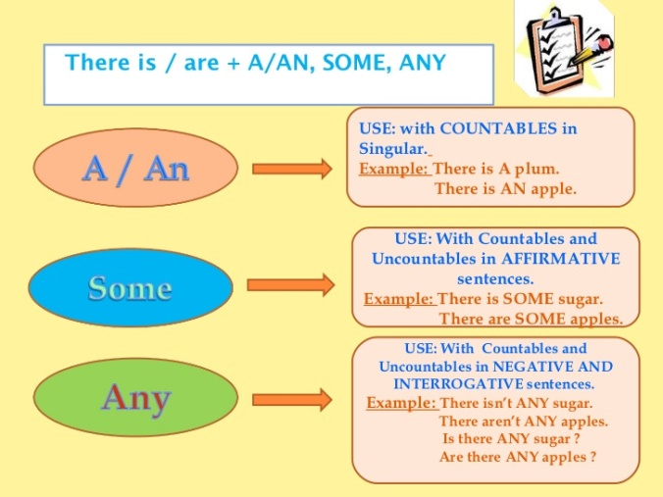
- There… a mirror in our hall.
- There… 12 cushions on the sofa.
- There… a big wardrobe in my sister's bedroom.
- There… children in the yard.
Complete with: there is/there isn’t/there aren’t/prepositions.
- There a box the bed.
- There a cat the wardrobe.
- There two dogs the room.
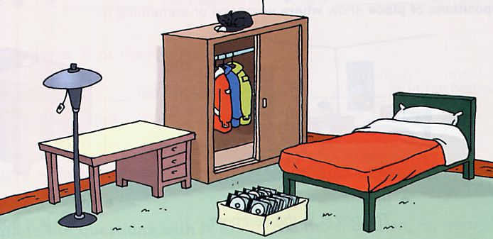
- There one CD the box
- There a computer the desk
- There a lamp the bed.
- There three jackets the wardrobe
- There two pillows the bed.
Complete with prepositions of place
- The music store is Santos Dumont Street and Rosa e Silva Avenue.
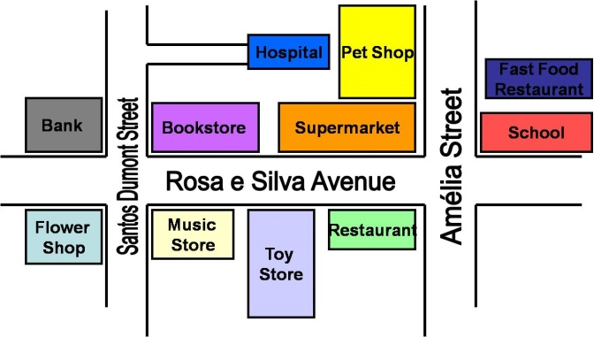
- The hospital is the pet shop.
- The toy store is the music store and the restaurant.
- The supermarket is the restaurant.
- The fast food restaurant is Amélia Street.
- The bookstore is the supermarket.
- The bank is Santos Dumont Street the flower shop.
- The school is Amélia Street and Rosa e Silva Avanue.
- The pet shop is Amélia Street.
- The flower shop is Santos Dumont Stree.

Complete with a/an/some/any

1. “Is there ... tea in this kitchen?” | 9. “Are there any girls in your class?” “No, there aren´t … “ | 17. The Browns haven’t got … children | 25. I haven’t got … books to read.
2. Sorry, there isn’t … more tea. | 10. Are there … lamps in the house? | 18. Have the Collins got … children? | 26. Is there … book on the table?
3. Has Mr. Evans got … coffee? | 11. This is … interesting newspaper. | 19. “Is there any coffee in the kitchen?” “Yes, there is.....” | 27. There are … cups of tea on the table.
4. Have the Evans got … flat? | 12. “Have you got any glasses?” “No, I haven’t got …” | 20. Have you got … chair for me? | 28. Is there … beer in the glasses?
5. There aren’t … flats to rent. | 13. There isn’t … water in the glass. | 21. “Is there any coffee in the cup?” “Yes, there is …” | 29. There isn’t … beer in the bottle.
6. Are there … boys in this class? | 14. In the park there are … very nice trees. | 22. I’m reading … interesting book. | 30. Mrs Green is having … coffee with milk.
7. We haven’t got … cinemas here. | 15. Mr. Smith is having … bread. | 23. There are … children in the street. | 31. Is there … wine in the glass?
8. There are … girls in this class. | 16. “Is there any beer in the glass” “No, there isn’t | 24. Has Peter got … interesting books? | 32. Have they got … books?

- There is a bag on the table.
- There is a calendar on the wall.
- There are two posters in my room.
- There is a banana in this basket.
- There are six chairs in the kitchen.
- There are lots of books in the shelf.
- There is a mirror in our hall.
- There are 12 cushions on the sofa.
- There is a big wardrobe in my sister's bedroom.
- There are children in the yard.

- There isn’t a box under the bed.
- There is a cat on the wardrobe.
- There aren’t two dogs in the room.
- There isn’t one CD in the box
- There isn’t a computer on the desk
- There isn’t a lamp near the bed.
- There are three jackets in the wardrobe
- There aren’t two pillows on the bed.

