Inglés. Tema 5
VOCABULARY
School subjects

  - Arte y diseño
  - Inglés:
  - Francés:
  - Geografía:
  - Historia:
  - Tecnología de la información:
  - Literatura:
  - Matemáticas:
  - Música:
  - Educación Física:
  - Ciencias:
Daily routines

  - Levantarse:
  - Ducharse:
  - Vestirse:
  - Tocar el piano:
  - Empezar la escuala:
  - Finalizar la escuela:
  - Hacer los deberes:
  - Cenar:
  - Limpiar la habitación:
  - Ir a la cama:

GRAMMAR
- Questions with the verb to be: Where are you from?

- Questions with the verb to have: Where have you got a cat?

- Questions with the verb not to be: Where do you study English?
¿Cuántos años tienes?
¿Cuál es tu nombre?
¿Qué día es hoy?
¿De donde eres?
¿Cuáles son tus hobbies?
¿Cuándo es el cumpleaños de tu madre?
¿Quién es tu mejor amigo?
¿Qué asignaturas te gustan?
¿Cuántos bolígrafos tiene él?
¿Estudia inglés (el)?
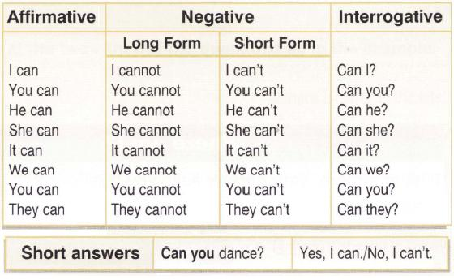
¿Quién soy yo?
- Remake the sentence with can
Karen meet . can't her Walter friend

the ? visit Can Jacksons England

ride his John new . can bike
- Write a negative sentence with can:
.
- Write a question with can:
?

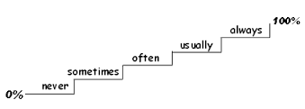
- Adverbs of frequency
How often do you…?

Put the adverb of frequency on the right place.
1. He listens to the radio. (often)
_____________________________
2. They read a book. (sometimes)
_____________________________
3. Pete gets angry. (never)
_____________________________
4. Tom is very friendly. (usually)
_____________________________
5. I take sugar in my coffee. (sometimes)
_____________________________
6. Ramon is hungry. (often)
_____________________________
7. My grandmother goes for a walk in the evening. (always)
_____________________________
8. Walter helps his father in the kitchen. (usually)
_____________________________
9. They watch TV in the afternoon. (never)
_____________________________
10. Christine smokes after dinner. (always)
_____________________________
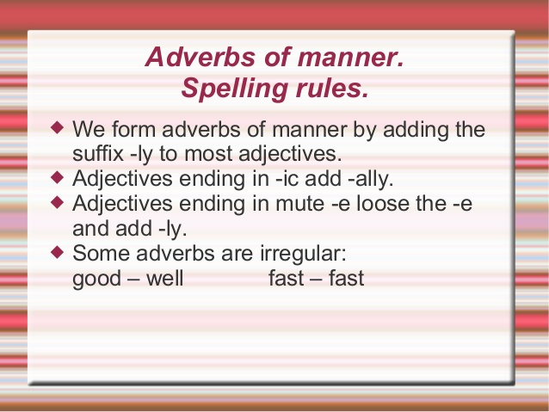
- Adverbs of manner
nice -
loud -
sad -
quick -
happy -
beautiful -
slow -
angry -
easy -
hungry -
quiet -
careful -
Fill in the correct form of the adverb:
Remember: good – well; hard – hard; fast – fast; late - late Embarrassed Smile Big smile
Anna was singing .(beautiful)
Don’t eat your lunch so . (fast) It’s not healthy.
Albrecht Dürer painted . (beautiful)
Mr Hill drives . (careless)
She did in her exams. (good)
I opened the door . (quiet)
Bruce ate dinner . (fast)
George was shouting . (angry)
Brad runs . (slow)
The students worked for the test. (hard)
The boys won . (easy)
Tim didn’t do very in his exam. (good)
Listen before you answer my questions. (careful)
The boat sank. The people shouted for help . (loud)
The little child crossed the street . (safe)
“Excuse me, madam, may I sit here?” the boy asked . (polite)
Jenny plays the piano . (good)
My boss came into my office. (direct)
They left the theatre. (quick)
He always comes because he hasn’t got a watch. (late)
She waited in front of the hospital . (patient)
The boy was hungry – he was eating . (greedy)
Babs lost her doll. She went home . (sad)

