1. The Greeks trusted the stars to forecast the future between 5000 and 3000 BC.
2. It was the Egyptians who first used astrology to foretell the character of a person based on their date of bird.
3. Astrology began to decline in popularity after Rome fell.
4. Christianity claimed it was the work of the devil.

They took up the practice of astrology for their own uses. St. Thomas Aquinas, for example, believed that the planets controlled everything

1. During the last century, astrology rose in popularity through several astrology magazines.
2. While some still refuse to believe in its predictions, just as many take it very seriously.



Astronomy is a science that studies everything outside of the earth's atmosphere, such as planets, stars, asteroids, galaxies

Astronomers base their studies on research and observation

Astrology on the other hand, is the belief that the positioning of the stars and planets affect the way events happen in real life

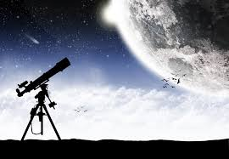

1. A horoscope is the picture of the planets during the birth of any person which differs from people to people, due to the continuous movement of the planets.
2. The belief that the relative positions of stars and planets have some influence over the lives of humans

**Astrology**

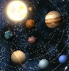

1. Aries is full of life and possesses high energy, which makes this sign always looking for a challenge.
2. **Tarus’s** symbol is the bull because this sign’s characteristic is to be peaceful and methodical.
3. The **Gemini** symbol is that of a pair of twins. This is because this sign rarely likes to do anything alone.
4. The crab symbolizes this sign for good reason. Just as the crab carries its own shell on its back, so the typical **cancer** person is all about home and family and is very dedicated and loyal to friends and family.
5. The lion is the symbol for this sign because the lion embodies the best characteristics of the **leo**; proud, relaxed, and in charge.
6. **Virgo**. Their minds are never quiet; always thinking, calculating, assessing. They loves making something out of nothing.
7. **Libra** people tend to need balance in their lives like no other sign of the zodiac. Libra people need to keep a balance between work lives and recreational lives and an equal balance in their emotional and spiritual/physical lives.
8. The symbol for **Scorpio** is the scorpion. The scorpio person is not necessarily aggressive on its own, unless they are provoked.
9. **Sagitarius**. The centaur is the symbol for this sign. In mythology, the centaur was half man and half horse, given to pursing pleasure. The centaur is shown with a bow, which he shoots. Wherever the arrow lands, the centaur follows, retrieves the arrow and shoots again. Those born under this sign will love travelling, discovering new things, meeting new people, and learning new things.
10. The mountain goat is the symbol for this sign because of the characteristic of the goat to climb higher and higher without losing his footing. **Capricorn** people are the type that are goal oriented and driven to succeed despite all the problems.
11. The man who carries the pitcher of water is the symbol for this sign. This is because **Aquarians** are often generous with their time and resources
12. **Piscis**. The fish is the symbol given to this sign. They are tremendously dedicated individuals, staying with companies for decades where others move from one job to the next. So, too, with relationships.

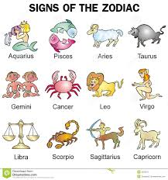

Subjective validation is the tendency for people to consider a statement or idea as being true, if it has any personal meaning, and in a positive way.

Example: You pride yourself as an independent thinker.

Subjective validation is an essential element of any successful [cold reading](http://skepdic.com/coldread.html) done by [astrologers](http://skepdic.com/astrolgy.html), [palm readers](http://skepdic.com/palmist.html), [tarot readers](http://skepdic.com/tarot.html), [and mediums](http://skepdic.com/medium.html).

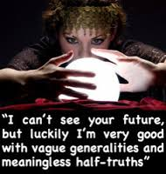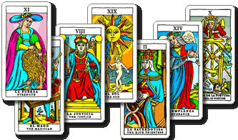

A tarot deck is a deck of cards, usually 78 cards, that is used by someone who is skilled in the reading of them.

Depending on the type of reading that you are wanting to have, the reader will consult the cards to show them what you are needing to know.

Numerology is any belief in the relationship between a [number](https://en.wikipedia.org/wiki/Number) and one or more [coinciding](https://en.wikipedia.org/wiki/Coincidence#Interpretation) events

* On 1/1/1999 the Euro was introduced in exactly **11** countries.
* The 2004 Indian Ocean tsunami – “[the deadliest tsnunami ever](http://geography.about.com/od/hazardsanddisasters/a/deadliest-tsunamis.htm)” – was on 12/26.   1+2+2+6 = 11.
* “Fukushima tsunami” was on 3/11/11.